**Experiment 2.2**

**Name :- Yash Gupta Uid :- 20BCS5009**

**Course :- CSE Section :- 709-A**

**Subject :- Programming in Python Subject Code :- 20CSP-259**

1. Write a Python program to get a list, sorted in increasing order by the last element in each tuple from a given list of non-empty tuples.

**Code:-**

**def last_element(n):**

**return n[i]**

**def sort_list(tuples):**

**return sorted(tuples, key=last_element)**

**i=-1**

**print(sort_list([(6, 2), (2, 8), (6, 9), (2, 3), (2, 1)]))**

**Output:-**

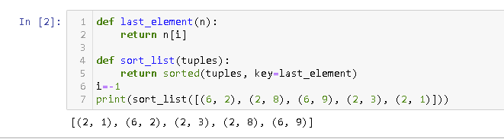

1. Write a Python program to print a specified list after removing the 0th, 4th and 5th elements, Sample List : ['Red', 'Green', 'White', 'Black', 'Pink', 'Yellow'],Expected Output : ['Green', 'White', 'Black']

**Code :-**

**list1 = ['Red', 'Green', 'White', 'Black', 'Pink', 'Yellow']**

**list1 = [x for (i,x) in enumerate(list1) if i not in (0,4,5)]**

**print(list1)**

**Output :-**

